DAY 1 – April 9
Lesson plan creator: Katie Lê
Class Time (minutes): 75
Grade Level: 8
SOLs:
8.RI.1A: Create a main idea statement and summarize key details.​
8.RI.1B: Analyze how authors develop ideas and connect evidence.​
8.RI.3A: Analyze how sections contribute to ideas.​
8.RI.3B: Compare how two authors present conflicting or complementary information.

Specific Class Objectives (Use Bloom’s Taxonomy with labels):
TSW…

- TSW read the IRW articles and annotate significant parts to evaluate how authors develop their arguments.​
- TSW compare solutions presented in two passages and determine their effectiveness based on text evidence.​
- TSW apply reading and test-taking strategies to answer comprehension questions accurately.
- TSW take a pre-test on the IRW unit to evaluate pre-existing knowledge on writing an IRW essay.

Technology Required: laptop, board, blooket game

Differentiation (levels of instruction):
Advanced: lexia provides differentiation that caters to student’s academic needs
Target: current lesson plan
Struggling: students can work in small groups/pairs with the IRW reading questions; TTW read the IRW articles aloud; TTW circle the parts of the SMART chart that students will need to write down; lexia provides differentiation that caters to student’s academic needs

Modification/Accommodations:
ESL learner: N/A

Student with an IEP (Individualized Education Plan):
Ms. Williams does not have students with an IEP.
Materials Needed:
T: board, laptop, sticky notes, markers, SmartPals, printed copies of readings, printed copies of reading questions and practice
S: laptop, pencil, expo marker
Focus Activity/Anticipatory Set: (Timeframe: 15 minutes, and Multiple Intelligences: linguistic, logical, intrapersonal)
TSW take a pre-test for the unit; pretest will be multiple choice questions about text features, test taking strategies, and parts of an essay.
Q: IRW Pre-test.docx

Direct Teaching / Modeling: (Timeframe: 8 minutes, and Multiple Intelligences: spatial, logical, interpersonal)
TTW review test taking strategies for reading assessments using an anchor chart. TTW will use the equity wheel to call on students to read aloud each skill and for the answer to the missing blank. TSW follow along and fill in the blanks on a SmartPal.
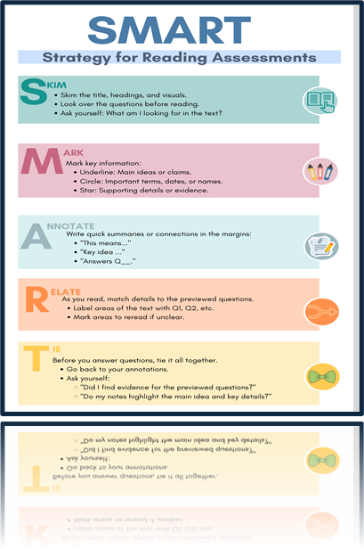
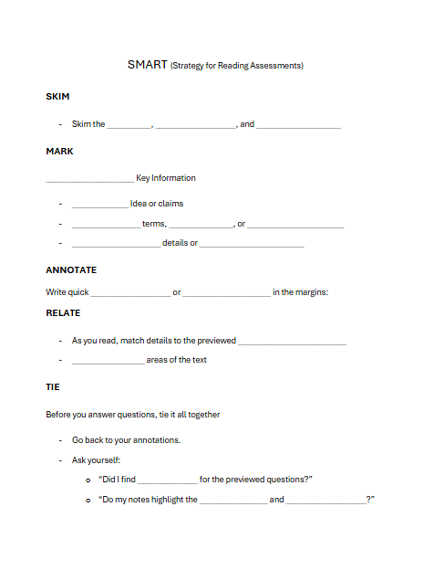

Q: What are test taking strategies that will help me be successful on a reading assessment?
Check for Understanding: (Formative Assessments)
Discussion and participation on the SMART reading strategies.
Part of closure, TTW use equity wheel to call on students for their answers on the reading questions.
Q: What strategies or skills helped with identifying the correct answer?
Q: What parts of a text can be annotated to help better understand the information?
Guided Practice: (Timeframe: 10 minutes, and Multiple Intelligences: spatial, linguistic, logical)
TTW read the articles aloud while students follow along. TSW annotate texts that stand out to them.
Answer Key_ Marine Ecosystems.docx

Q: What parts of a text can be annotated to help better understand the information?
Independent Practice: (Timeframe: 20 minutes, and Multiple Intelligences: logical, intrapersonal, interpersonal, linguistic)
TSW may work alone or in pairs to answer questions about both passages. To review their answers, TTW use the equity wheel to call on students for their answers.
Q:
Copy of IRW_ Marine Ecosystems.docx
Answer Key_ Marine Ecosystems.docx

Closure: (Timeframe: 20 minutes, and Multiple Intelligences: spatial, bodily-kinesthetic, logical, intrapersonal)
Finally, TSW draw an animal or example of plastic waste mentioned in one of the texts. If students finish early, they will work on Lexia.
Q: What is an animal or example of plastic waste mentioned in one of the texts?
Evaluations: Discussion and participation about the SMART reading strategies; discussion and participation on the IRW readings
Formative: Unit Pre-test; students answering questions on the content of the IRW articles; identifying animal/plastic waste from the articles

DAY 2, April 10
Lesson plan creator: Katie Lê
Class Time (minutes): 75
Grade Level: 8
SOLs:
8.W.1 B. Write expository texts to examine a topic or concept that conveys ideas and information by maintaining a clear focus with relevant, well-chosen facts, definitions, concrete details, quotations, and examples from multiple credible sources, using structures and patterns (e.g., description, enumeration, classification, comparison, problem-solution, or cause-effect) to clarify relationships among ideas and concepts.​
​
8.W.2 A. Generate and organize ideas using the writing process (planning, drafting, revising, editing) to develop multi-paragraph texts.

Specific Class Objectives (Use Bloom’s Taxonomy with labels):
TSW…
- TSW effectively annotate and analyze a writing prompt.​
- TSW use an informational text along with the prompt to begin planning their expository essay.
- TSW write topic sentences based on a provided prompt.

Technology Required:
Laptop, board, presentation, blooket
Differentiation (levels of instruction):
Advanced: lexia provides differentiation that caters to student’s academic needs
Target: current lesson plan
Struggling: students can work collaboratively in blooket game; for annotating activity, TTW walk students through the assignment step by step, using the board; students will have the T-Bar labeled on the board

Modification/Accommodations:
ESL learner: N/A
Student with an IEP (Individualized Education Plan):
Ms. Williams does not have students with an IEP.
Materials Needed:
T: Laptop, board, T-Bar worksheets, IRW prompt, SmartPals
S. laptop, writing utensil
Focus Activity/Anticipatory Set: (Timeframe: 3 minutes, and Multiple Intelligences: spatial, logical, interpersonal, intrapersonal)
TSW play a blooket reviewing the content from the Marine Life and Mirco Plastics article.
https://dashboard.blooket.com/set/67eeab61643f340e95503d18
Q: What are these articles about?
Direct Teaching/Modeling: (Timeframe: 3 minutes and Multiple Intelligences: linguistic)
TTW read the sample IRW prompt for the unit.
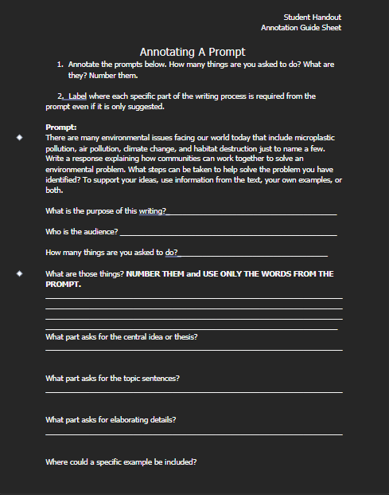
Q: What is the purpose for writing the essay?
Q: How many steps is the prompt asking you to do?
Check for Understanding: (Formative Assessments)
Discussion and participation about annotating the given prompt.
Q: What is the prompt asking you to do?
Q: What is the purpose for writing the essay?
Guided Practice: (Timeframe: 10 minutes, and Multiple Intelligences: logical, interpersonal, intrapersonal, linguistic)
TSW work independently to answer the questions on annotating the prompt on a SmartPal. TTW use the equity wheel to call on students to go over the answers.

Independent Practice: (Timeframe: 15 minutes, and Multiple Intelligences: logical, linguistic)
TSW work in small groups/pairs to complete a T-Bar practice worksheet on topic sentences.
Unit 7, Gr. 8 T-Bar Practice.docx

Q: How do I use the provided prompts to create a topic sentence when planning an essay?
Closure: (Timeframe and Multiple Intelligences: logical, intrapersonal)
TSW independently start their web by writing the topic sentence. TTW check the topic sentence before the student can move on to the rest of the web for next class. If students finish early, they will work on Lexia.
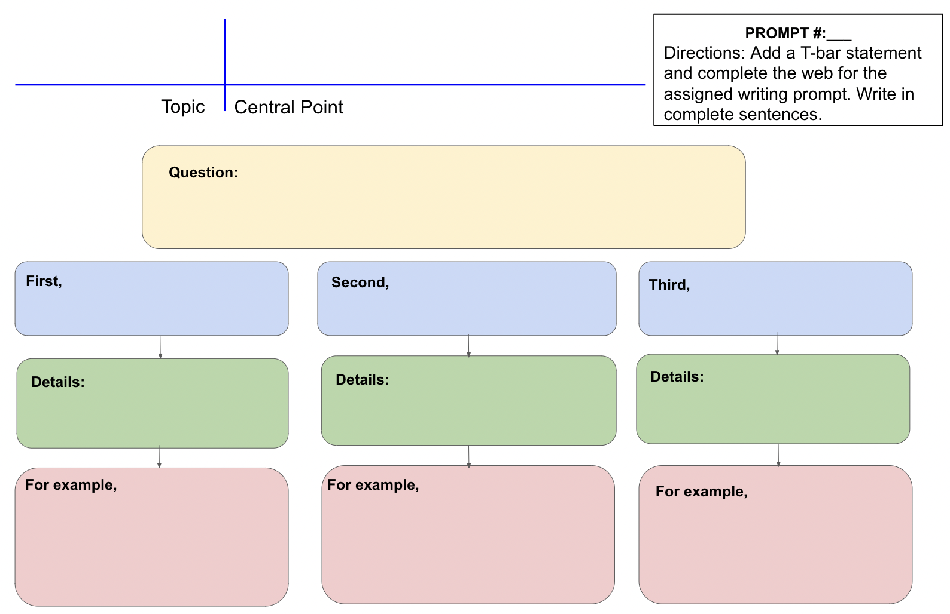
Q: What goes into an effective topic sentence?
Q: What is the prompt asking you to do?
Evaluations: discussion and participation on annotating prompts; creating topic sentences
Formative: annotating prompts; creating topic sentence t-bars; topic sentence for IRW

DAY 3 – April 11
Lesson plan creator: Katie Lê
Class Time (minutes): 75
Grade Level: 8
SOLs:
8.W.1 B. Write expository texts to examine a topic or concept that conveys ideas and information by maintaining a clear focus with relevant, well-chosen facts, definitions, concrete details, quotations, and examples from multiple credible sources, using structures and patterns (e.g., description, enumeration, classification, comparison, problem-solution, or cause-effect) to clarify relationships among ideas and concepts.​
8.W.2 A. Generate and organize ideas using the writing process (planning, drafting, revising, editing) to develop multi-paragraph texts.

Specific Class Objectives (Use Bloom’s Taxonomy with labels):
TSW…
- TSW use text evidence to help develop ideas during the pre planning process of their expository essay. ​
- TSW organize their ideas from their web into an essay.
- TSW identify parts of an essay using a sample essay.

Technology Required:
Laptop, board, IRW review canva presentation, lexia, blooket

Differentiation (levels of instruction):
Advanced: lexia provides differentiation that caters to student’s academic needs
Target: current lesson plan
Struggling: students will work collaboratively on identifying parts of an essay; lexia provides differentiation that caters to student’s academic needs;

Modification/Accommodations:
ESL learner: N/A
Student with an IEP (Individualized Education Plan):
Ms. Williams does not have students with an IEP.
Materials Needed:
Laptop, exit ticket, student template webs,
Focus Activity/Anticipatory Set: (Timeframe: 5 minutes, and Multiple Intelligences: spatial, logical, intrapersonal, interpersonal)
TSW play a review blooket in classic mode about introduction paragraphs.
Q: What are parts of an introduction paragraph?
Direct Teaching/Modeling: (Timeframe: 8 Minutes, and Multiple Intelligences: spatial, interpersonal, intrapersonal)
TTW review how to create a template for the IRW sample writing by having students answer questions on what goes into an essay.

https://www.canva.com/design/DAGj42PdJl0/oPBlFcwLUdr3eiUptB7l2Q/edit?utm_content=DAGj42PdJl0&utm_campaign=designshare&utm_medium=link2&utm_source=sharebutton

Q: What are the parts of an essay?
Q: How can I set up a template in order to prepare for an IRW essay?
Check for Understanding: (Formative Assessments)
TSW use a sample essay and identify the significant parts of the essay.
Guided Practice: (Timeframe: 10 minutes, and Multiple Intelligences: spatial, logical, interpersonal)
TSW may work alone or in pairs in using a sample essay to identify the significant parts of the essay.
Identifying parts of an essay - Exemplar for Unit 7

Independent Practice: (Timeframe: 10 minutes, and Multiple Intelligences: logical, intrapersonal, linguistic)
TSW independently finish their webs to create their own templates for the sample IRW prompt. On the back on their webs, Students will write their conclusion.
Q: How can I successfully set up a template to prepare for writing an IRW essay?
Q: What are the significant parts of an essay?
Closure: (Timeframe: 5 minutes; and Multiple Intelligences: linguistic, logical, intrapersonal)
TSW complete an exit ticket reviewing the requirements for an effective introduction paragraph. If students finish early, TSW work on Lexia.
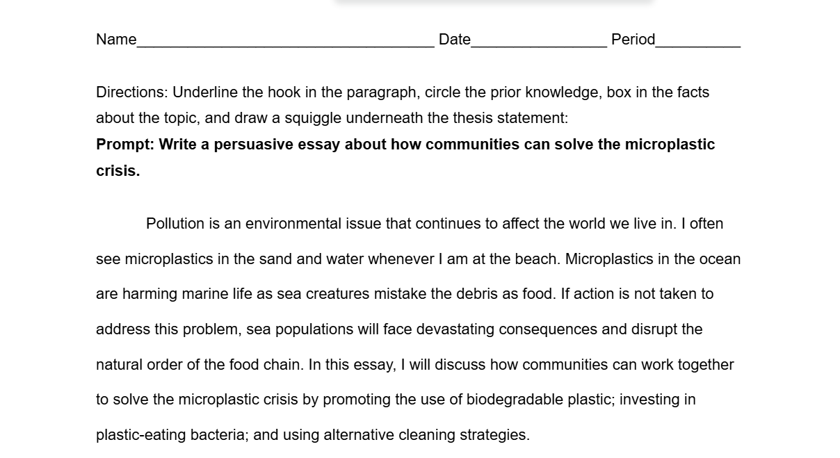

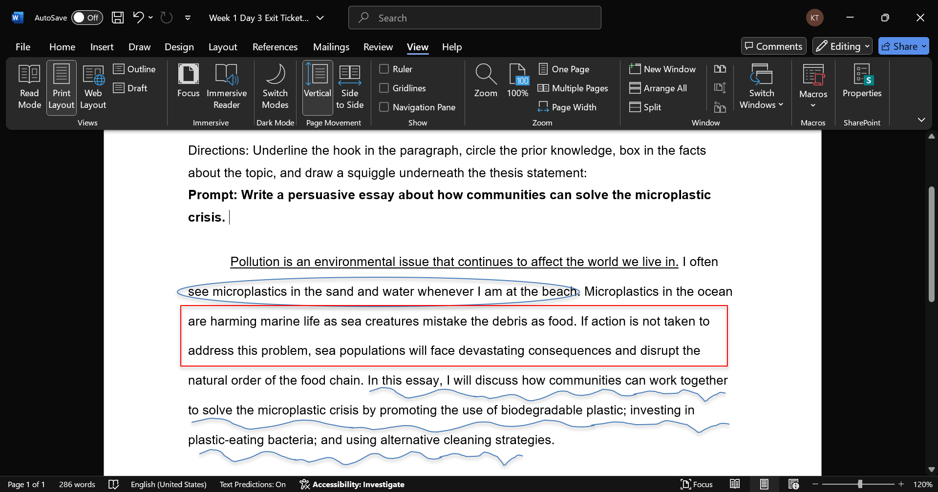

Q: What are the four requirements for an effective introduction paragraph?
Evaluations: discussion and participation about parts of an essay, identifying parts of a essay using a sample essay
Formative: exit ticket and blooket reviewing introduction paragraphs

Sources: All plans are structured around the Hampton City Schools curriculum which is required to be used by Roanoke City Public Schools
Unit 7 Week One.pptx
Unit 7 Week 2.pptx
hcs-resourceinquiries@hampton.k12.va.us

